

Intelligent Vaccine Cold Storage Monitoring System

A REPORT
In
CSA1012 –Software Engineering
Submitted in the partial fulfillment for the award of the degree
Of
BACHELOR OF ENGINEERING
IN
INFORMATION TECHNOLOGY
Submitted by:
B.Shyam raj(192421176)

Supervisor/Advisor Name:
Dr. K. Anita Devamani,
Professor/CSE

SAVEETHA INSTITUTE OF MEDICAL AND TECHNICAL SCIENCES
CHENNAI-602105
Section | Title | Page
— | Title Page | 1
1 | Introduction | 2
1.1 | Problem Statement Recap | 2
1.2 | Objectives Mapped to This Assignment | 2
1.3 | System Architecture Overview | 2
2 | Version Control with Git | 4
2.1 | Repository Structure | 4
2.2 | Branching Strategy | 4
2.3 | Core Git Workflow & Commands | 5
2.3.1 | Initializing the repository | 5
2.3.2 | Feature branch workflow (example: ML prediction service) | 5
2.3.3 | Tagging a release | 5
2.3.4 | Hotfix example (critical excursion-detection bug) | 5
2.3.5 | Inspecting history & audit trail | 6
2.4 | .gitignore | 6
2.5 | Commit Message Convention | 6
3 | Containerization with Docker | 9
3.1 | Container Architecture | 9
3.2 | Dockerfile — Sensor Ingestion Service (Node.js) | 9
3.3 | Dockerfile — ML Prediction Service (Python) | 9
3.4 | Dockerfile — Dashboard (React, multi-stage build) | 10
3.5 | docker-compose.yml | 10
3.6 | Build, Run & Verify Commands | 11
3.6.1 | Scaling a service across facilities | 11
3.6.2 | Pushing images to a registry | 11
3.7 | Volumes & Data Persistence | 11
3.8 | Health Checks & High Availability | 11
4 | Integrating Git and Docker: CI/CD Pipeline | 12
5 | Compliance, Audit & Security Considerations | 13
6 | Conclusion | 14

1.Introduction

Vaccine potency depends on an unbroken cold chain, and a single undetected temperature excursion in a refrigeration unit can silently destroy an entire stock of doses before anyone notices. The Intelligent Vaccine Cold Storage Monitoring System addressed in this assignment is an IoT- and AI-enabled platform that continuously observes temperature, humidity, power status, and refrigerator health across hospitals, clinics, blood banks, and vaccination centres, predicts equipment failures before they occur, and instantly alerts healthcare staff so that corrective action can be taken in time.

This document is not a description of the monitoring platform itself; it is a technical assignment that demonstrates how the engineering team responsible for building that platform would apply Git for version control and Docker for containerization across its development lifecycle. It covers repository design, branching strategy, everyday Git commands, Dockerfiles for each microservice, a docker-compose orchestration layer, and the commands used to build, run, and verify the containerized system, along with the diagrams, tables, and terminal transcripts that a reviewer would expect to see.

Problem Statement Recap

Design and develop an IoT-enabled Intelligent Vaccine Cold Storage Monitoring System that continuously monitors vaccine storage conditions across hospitals, clinics, pharmacies, blood banks, and vaccination centers, uses AI/predictive analytics to detect abnormal conditions and forecast refrigeration failures, sends instant multi-channel alerts, maintains audit-ready historical logs, and generates automated regulatory compliance reports — deployable at scale with secure data transmission and high availability.

1.2 Objectives Mapped to This Assignment
Objective | How Git/Docker Supports It
Continuous monitoring & real-time data collection | Each sensor domain runs as an independent, restart-resilient Docker container so ingestion never stops during a deploy.
Immediate excursion detection & failure prediction | The ML container is version-controlled on its own Git branch so models can be retrained/rolled back without touching other services.
Instant multi-channel notification | notification-svc is decoupled into its own image/container and can be scaled or redeployed independently.
Audit trails & compliance reporting | Git commit history itself becomes part of the audit trail; the compliance-api container generates exportable reports.
Scalable, multi-facility deployment | docker-compose (and Compose scale flags) let the same image set be replicated per facility or region.

1.3 System Architecture Overview
Before defining the repository and container layout, it helps to fix the target architecture the DevOps setup must serve. Sensors feed an edge gateway, which forwards data into a set of containerized cloud services covering ingestion, ML-based prediction, storage, alerting, and compliance reporting, finally surfaced through a dashboard.
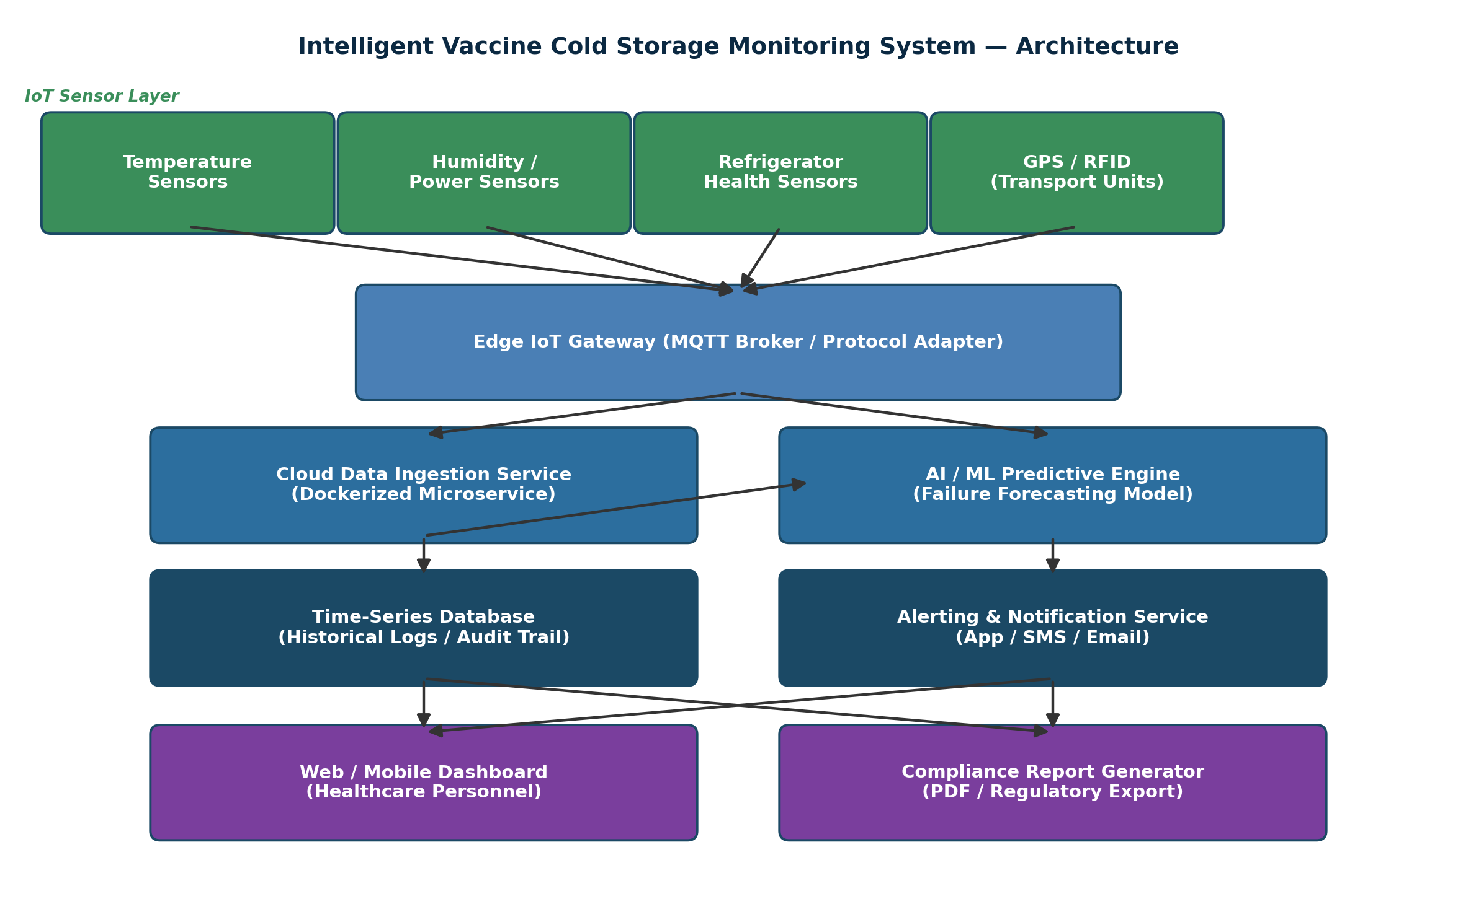
Figure 1. End-to-end system architecture of the vaccine cold storage monitoring platform.

2.Version Control with Git

Git is used to manage the source code of every microservice, the infrastructure-as-code (Dockerfiles, docker-compose.yml), and documentation, giving the team a complete, traceable history of how the cold-chain platform evolved — which is itself valuable evidence during a regulatory audit.

2.1 Repository Structure

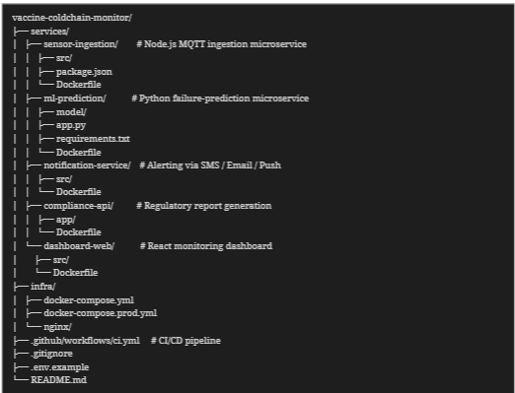

2.2 Branching Strategy

The project follows a Gitflow-style model. main always reflects what is running in production facilities; develop is the integration branch; each feature branch is scoped to a single microservice or capability (for example feature/sensor-ingestion, feature/ml-prediction, feature/alert-service) so that a defect in one service's history never blocks another; release/* branches stabilise a version before it is tagged and merged to main; hotfix/* branches patch production directly when a cold-chain-critical bug is found.

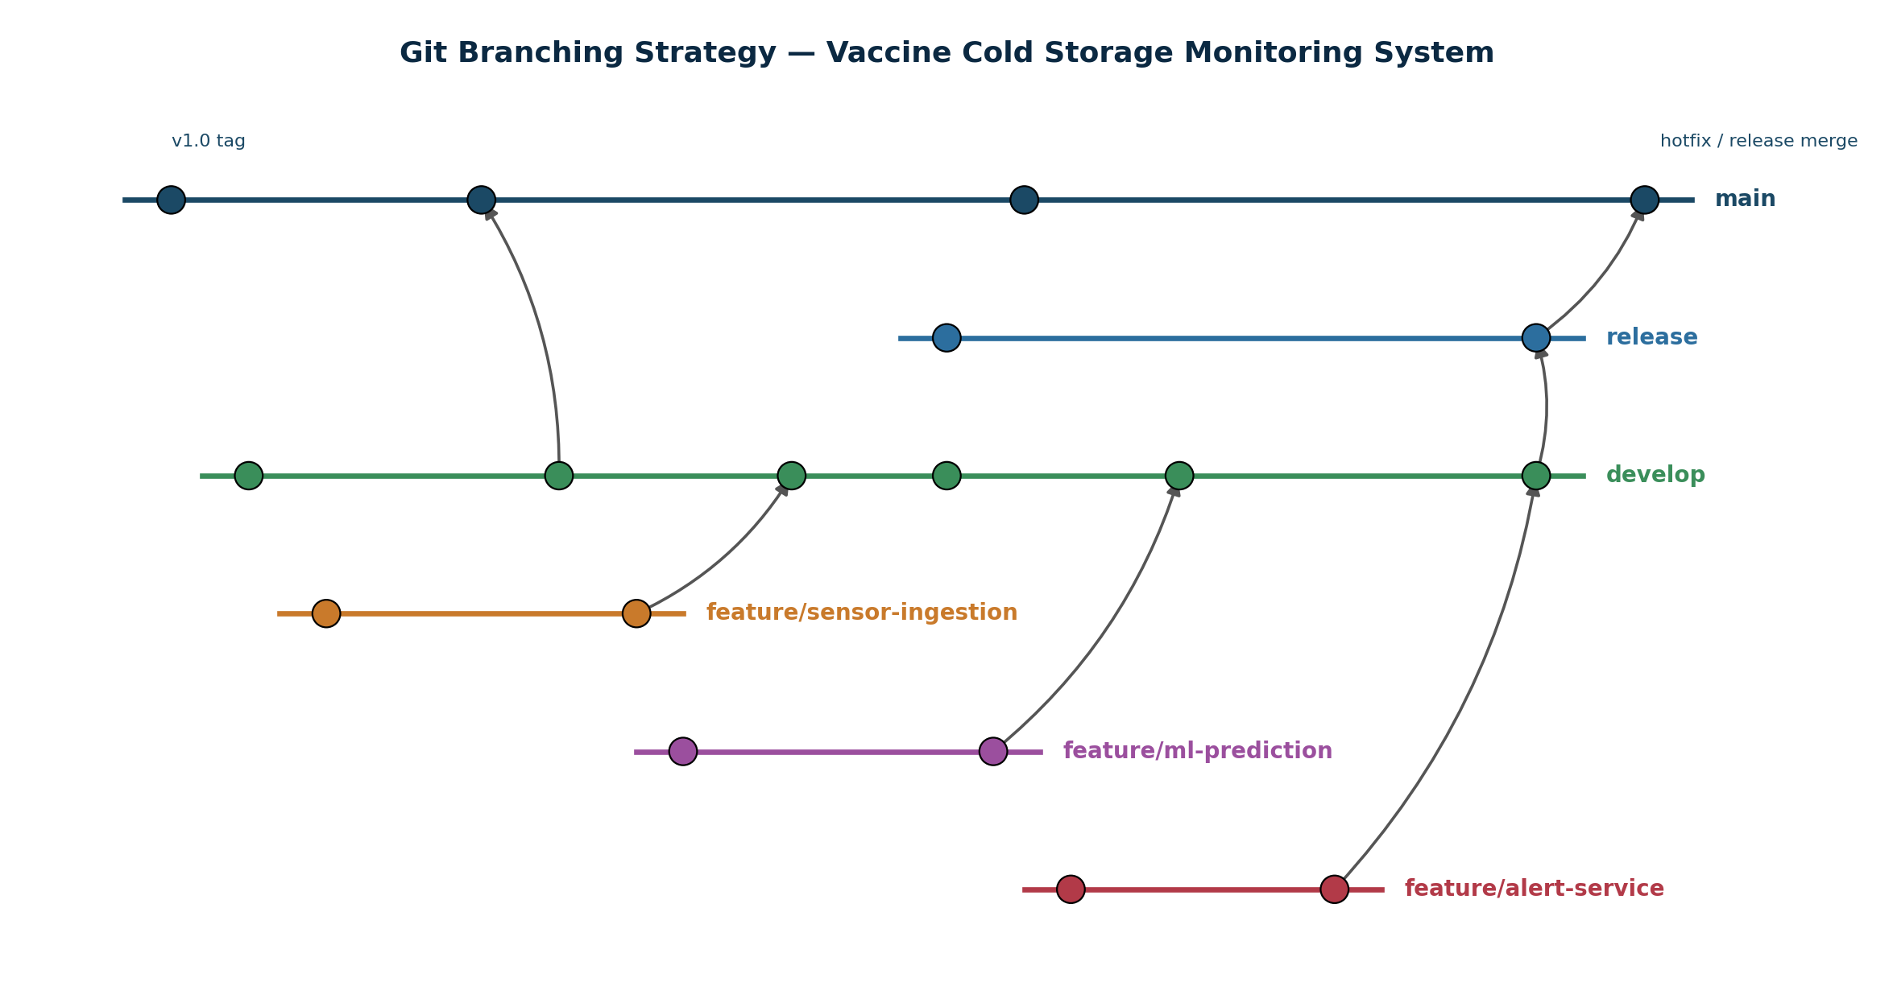

Figure 2. Git branching model used for the monitoring platform.

2.3 Core Git Workflow & Commands
Branch | Purpose | Notes
main | Production-ready code deployed to hospital/clinic facilities | Protected; only merges from release/* or hotfix/*
develop | Integration branch for the next release | Feature branches merge here first
feature/* | One branch per microservice/capability | Deleted after merge to keep the repo clean
release/* | Pre-release stabilisation and QA | Tagged with semantic version, e.g. v1.2.0
hotfix/* | Urgent production fix (e.g., false-negative temperature alert) | Merged to both main and develop

2.3.1 Initializing the repository

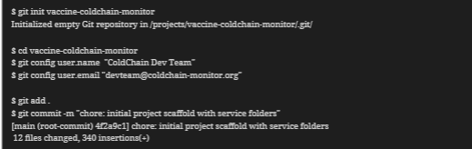

2.3.2 Feature branch workflow (example: ML prediction service)

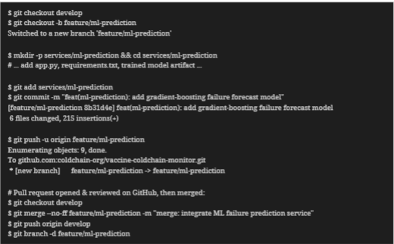

2.3.3 Tagging a release

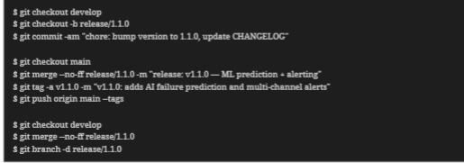

2.3.4 Hotfix example (critical excursion-detection bug)

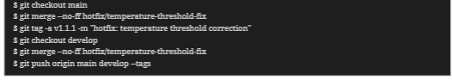

2.3.5 Inspecting history & audit trail

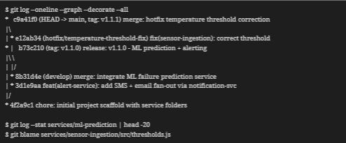

2.4 .gitignore

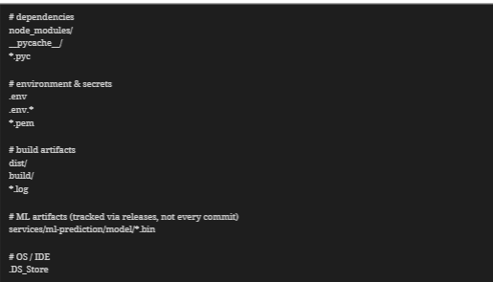

2.5 Commit Message Convention
The team follows Conventional Commits so that the Git history doubles as a readable audit log, which regulators reviewing cold-chain compliance can trace directly to code changes.
Type | Meaning | Example
feat | A new capability | feat(ml-prediction): add 24h failure probability score
fix | A bug fix | fix(notification-svc): retry SMS delivery on gateway timeout
chore | Tooling, config, version bumps | chore(docker): pin Node base image to 18-alpine
docs | Documentation only | docs: add compliance report schema

3. Containerization with Docker

Each capability of the monitoring platform runs as its own container so that, for example, redeploying the ML model never risks downtime on the alerting path — a hospital must never lose real-time excursion alerts because a data-science team is shipping a model update.

3.1 Container Architecture

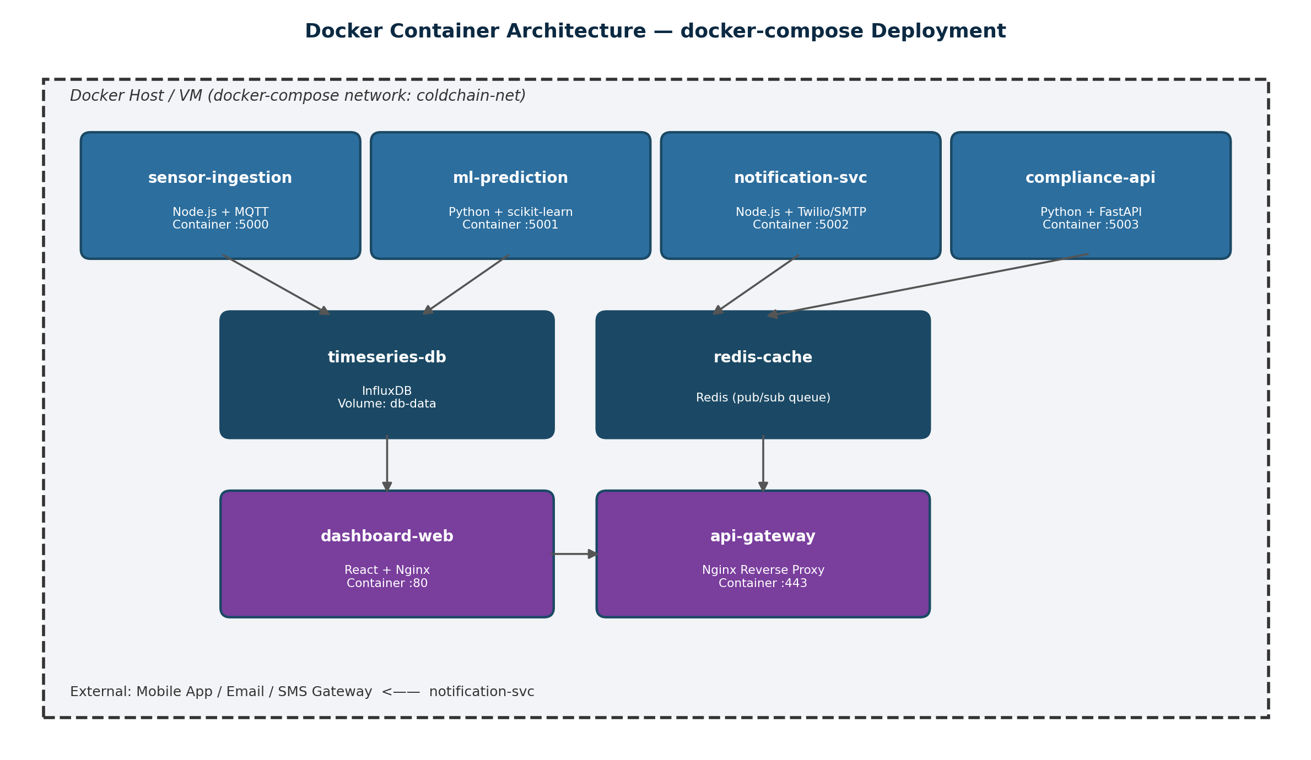

Figure 3. Containerized microservices orchestrated via docker-compose.

3.2 Dockerfile — Sensor Ingestion Service (Node.js)

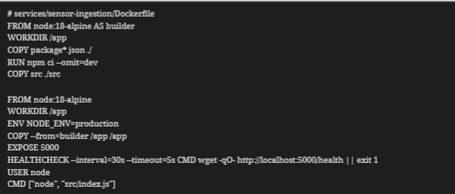

3.3 Dockerfile — ML Prediction Service (Python)

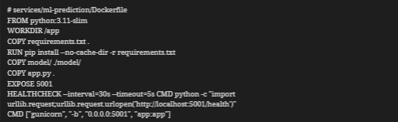

3.4 Dockerfile — Dashboard (React, multi-stage build)

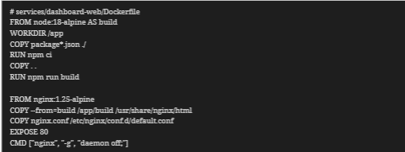

3.5 docker-compose.yml

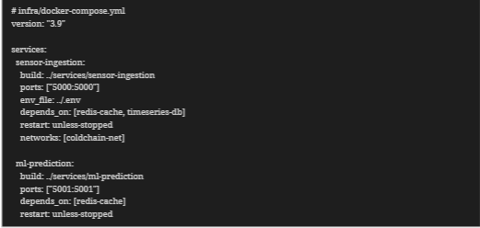

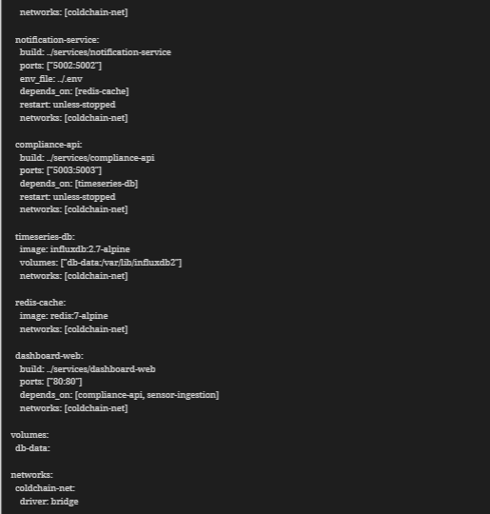

3.6 Build, Run & Verify Commands

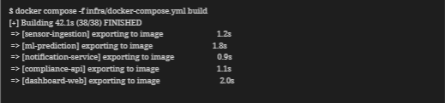

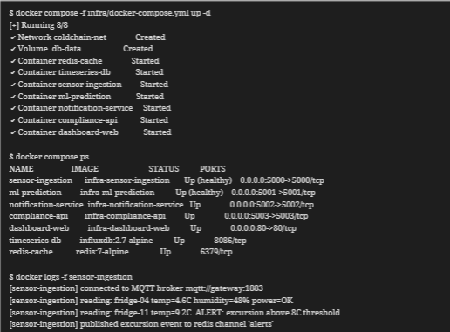

3.6.1 Scaling a service across facilities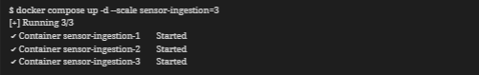

3.6.2 Pushing images to a registry
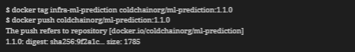

3.7 Volumes & Data Persistence
The timeseries-db container mounts a named volume (db-data) so that historical temperature/humidity logs and the audit trail survive container restarts, image upgrades, and redeployments — a regulatory necessity, since compliance reports must be reproducible months after the fact.

3.8 Health Checks & High Availability
Every long-running service defines a HEALTHCHECK so that docker compose ps and any orchestrator (e.g., Docker Swarm or Kubernetes in a later phase) can automatically restart a container that stops responding — directly supporting the platform's requirement for high system availability, since a silent container crash on the ingestion service would otherwise create an undetected blind spot in the cold chain.
On a successful build against main, the pipeline additionally pushes the tagged image to the container registry and can trigger a rolling docker compose pull && up -d at each facility gateway, giving the organisation a fully traceable path from a Git commit to a running container at a hospital's edge server.

4. Integrating Git and Docker: CI/CD Pipeline
Git and Docker are tied together through a continuous integration pipeline that builds and tests a container image on every push, so that a merge into develop or main only succeeds once the corresponding service is proven to build and pass its health check.
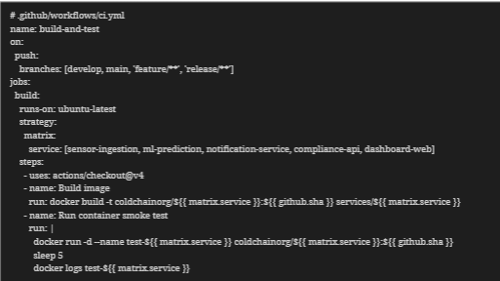

5. Compliance, Audit & Security Considerations
- Git as audit evidence: every threshold change, alert-logic fix, or model update is a signed, timestamped commit that can be presented to a regulator alongside the compliance report it affects.
- Protected branches: main requires pull-request review and passing CI before merge, preventing an unreviewed change from reaching a production cold-storage facility.
- Secrets management: credentials (SMS/email gateway keys, DB passwords) are excluded via .gitignore and injected at runtime through docker compose env_file / secrets, never baked into an image.
- Minimal base images: Alpine and slim variants reduce each container's attack surface and image size, which matters when pushing updates over limited clinic bandwidth.
- Immutable image tags: every release is tagged with both a Git tag (v1.1.0) and a matching Docker image tag, so a facility can be rolled back to an exact, previously audited version in minutes.
- Network isolation: the internal coldchain-net bridge network means only the dashboard and API gateway are exposed publicly; the database and cache are unreachable from outside the host.

6. Conclusion

Applying Git and Docker to the Intelligent Vaccine Cold Storage Monitoring System gives the engineering team the same discipline that the problem itself demands from hospitals: nothing is allowed to change silently. A Gitflow branching model keeps every microservice's history separable and reviewable, while a per-service Dockerfile and a single docker-compose.yml let the ingestion, prediction, alerting, storage, and reporting layers be built, tested, scaled, and rolled back independently and reproducibly. Together with health checks, immutable image tags, and a CI pipeline that ties a Git commit directly to a running container, this setup gives the platform the reliability, auditability, and scalable multi-facility deployment path called for in the original problem statement — directly supporting the goals of reduced vaccine wastage, faster failure response, and dependable regulatory compliance documentation.

